**Q: In high concentrations, you are dangerous. How will you account for this?**

It takes eating all your meals on a plate made completely out of copper for me to kill someone. There is also medicine that binds copper to certain chemicals so your body can get rid of it. Doorknobs and handrails made by me are also antimicrobial. If anything, I've been making the world healthier.  
  
  
**Q:** **What do you have to say about the corruption caused by copper, silver, and gold?**Our party is naturally valuable due to our rarity. We can do nothing about it, however paper money has increasingly been used instead of us for currency.

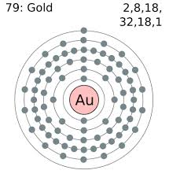

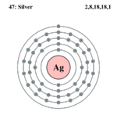

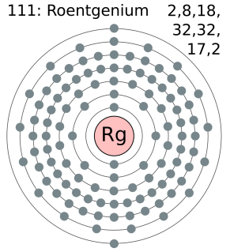

General Facts about Group 11

|  |  |  |  |  |
| --- | --- | --- | --- | --- |
|  | Copper | Silver | Gold | Roent-genium |
| Atomic Number | 29 | 47 | 79 | 111 |
| Atomic Mass | 63.546 | 107.8682 | 196.96 | N/A |
| Melting Point | 1385K | 1235K | 1337K | N/A |
| Boiling Point | 2835K | 2435K | 3,243 K | N/A |
| Common Physical Form | Shiny brown red metal | Shiny gray metal | Shiny yellow metal | N/A |
| Electron Configuration | [Ar] 3d10 4s1 | [Kr] 4d10 5s1 | [Xe] 4f14 5d10 6s1 | [Rn] 5f14 6d9 7s2 |
| Density | 8.933 g/cm3 | 10.501 g/cm3 | 19.282 g/cm3 | More than 19.282 g/cm3 |
| Cost in USD per pure gram | $9.76 | $120 | $5540 | N/A |

**Cu In the Election**

C what copper can do for U

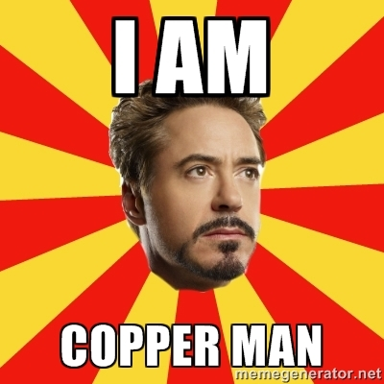

Campaign managed by:  
Jonathan Quang  
Shadman Khandaker

**Members of the Group 11 Coinage Metal Party**

* **Copper** : President of the party  
  -Used as currency and a lot of wiring and least dense of the party  
  -Incredibly useful
* **Silver** :VP of the party  
  -Shiny and reflective  
  -Always learning from past experiences
* **Gold**: Treasurer of the party  
  -Incredibly rich  
  -Useful in microscopic size electronics
* **Roentgenium**: Had a short lived career after being assassinated for being a synthetic element. Mentioned here in his honor.

Members of the Coinage Metal Party tend to be very wealthy candidates that keep the world connected. They are all highly conductive and soft metals. They are both ductile and malleable. In order from top to bottom, about 60 parts per million of the earth's crust is copper, then 0.0755 ppm, and 0.04 ppm.

**Who Is Copper?**

* In its purest form, copper is soft and malleable. Like most metals, it always forms bonds with oxygen. This forms verdigris that protects the rest of the copper from oxidation. This is why the Statue of Liberty created by the skillful copper has turned a greenish color.
* Copper is stable. It has two stable isotopes 63Cu and 65Cu along with 27 radioisotopes.
* Copper is also an excellent conductor of heat and electricity while also showing minimal thermal expansion. This makes copper an extremely popular element for use in wires.
* When combined with sulfur in different chemical compositions, they work together as a team to perform many different functions such as acting like a semiconductor or polarizer of infrared light.

**Life's not the Same Without Copper**

* Many crustaceans have blue blood because they do not have hemoglobin but rather hemocyanin, which contains copper.
* For every kilogram a human weighs, there is about two milligrams of copper in them in the form of enzymes. These enzymes assist in the formation of blood vessels, tendons, bones, and nerves.
* In all mitochondria of eukaryotes, cytochrome c oxidase, which is the last protein in oxidative phosphorylation, binds O2 between a copper and an iron.

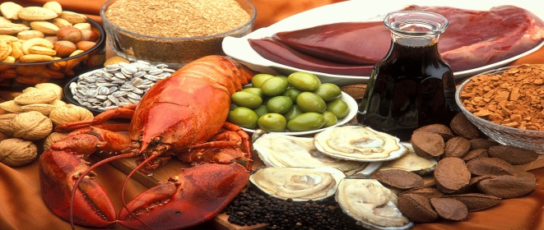

Without copper, there would be no food

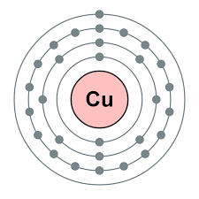

**What's Your Stance On These Issues?**

Q: **Do you believe there is an overreliance on you for electronics?**

A: Not one bit, I know for a fact that wiring with me is very cheap, which I am sure everyone enjoys.